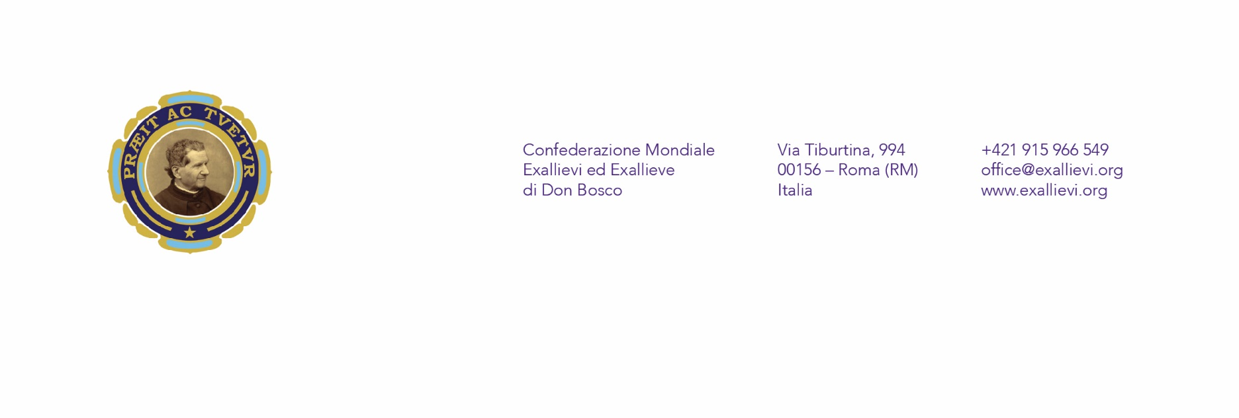

Dear President and members of National Presidency of Past Pupils,

I am writing to you with joy in my heart about the celebration of the 150th anniversary of our Association. On the 24.06.1870, when the first group of past pupils visited Don Bosco to mark his namesday and to thank him for the invaluable gift of education and friendship, the story of past pupils started. From the famous gift of coffee cups – „tazzine“ now after almost 150 years we are called to reflect the past, to enjoy the present and to plan for future challenges.
I would like to invite all past pupils from around the world to get prepared and to celebrate this special anniversary. For the occasion of 150th anniversary in 2020, the World Presidency of Past Pupils decided to announce a Jubilee Year of Past Pupils of Don Bosco.
The Jubilee Yearwill start on the day of the anniversary itself on the 24.06.2020 in Torino – Italy with our actual Don Bosco the Rector Major of the Salesian Family, during the celebration of the Namesday of Don Bosco. The Jubilee Year is meant to be year of reflection, celebration and planning. We want to give our thanks to Don Bosco and our mother Mary Help of Christians for all blessings we have received in the last 150 years. We would like to bring and present what we have and what we are to the Salesian Family, the Church and to the World. New initiatives, projects and ideas will be shared and presented. At the same time, 150th anniversary is very important moment for us to re-think our identity and set standards and answer the question: What does it mean to be a past pupil of Don Bosco in the 21st century? What kind of Association we want to be for next 150 years in order to grow, to build better networks, to bring new projects and to be salt of the earth and light of the world of today?
The Jubilee Year will end at the World Assembly of Past Pupils which is scheduled for 2021, where we would like to bring all the results and outputs of the Jubilee Year and put it together in a manifesto on the past pupils of don Bosco in 21st century.
I encourage you, my dear friends, to start your preparation for this extraordinary and blessed time of our Anniversary. I encourage you to prepare your own national and local activities and celebrations. At the same time, I invite you to be part of the international celebrations on various opportunities, to join the world movement of past pupils and to let know about our joy and gratitude which we have in our hearts. Now even more than 150 years ago.
The whole year of 2019 will be among other activities, an important time of preparation for upcoming celebrations. The World Presidency will be sharing with you new suggestions, proposals and ideas, and we will be asking you for your opinions and your ideas as well. We would like to reflect on the identity and mission of past pupil of today and for that process we would like to invite you all. To create results, motivate each other and to bring all of this to life.
We want to reflect on the scheme which we call 3P of past pupils‘ identity and mission – Personal, Professional and Pastoral. All these parts of our life bring different needs, challenges and approaches for us as past pupils, and futhermore as members of the Salesian Family, which see in the youth, specially the most needy, a special destinatary of our attention and actions. Let´s rethink it at personal, local, national but also worldwide level.
We, as a world presidency, will inform you soon about next steps in the issue of upcoming Jubilee year and we will provide all necessary also in all of our official languages.
Dear friends, I am very happy we are living in such times, that we witness the fruits of the dreams of Don Bosco, when we ourselves can be and become this fruit. As our story started with coffee cups, they need to be filled with our love, gratitude and undying will to be good Christians and honest citizens.
In don Bosco
Michal Hort

